1

*Msc in Advanced general dental Practice Ulster University*

*Student ID Number B00923634*

*Module*

Basic Sciences, Biomaterials, Health Promotion and Minimal

Dentistry (DEN763) PART -A

*Essay Question*

*PART-B  
Treatment plan and diagnosis*

*Date of Submission 10 July 2023*

2

*Essay Introduction; - The oral microflora also known as the Oral microbiome is a complex ecosystem where several species of microorganisms have been identified.1[ Palmer RJ Jr et al. , 2008]The predominant groups present in the mouth include Streptococcus, Neisseria, Veillonella, Actinomyces and other obligate anaerobes.2[ Avila M et al,.2009]The oral microbiome is particularly crucial to health because it can cause both oral and systemic disease. he oral microbiome lodges within biofilms throughout the oral cavity, forming an ecosystem that maintains health when in equilibrium.. Every human body contains a characteristic microbiome that is necessary to maintain homeostasis. These micro organism have an inherent functionality of synthesizing nutrients like B and K, assisting in digestion, and stopping colonization through pathogens,, but can evoke disease in case of imbalance with a shift in the equilibrium state allowing pathogens to manifest and cause disease. Oral microflora is most commonly found in gingival crevices, coronal plaques, tongue dorsum, buccal mucosa and saliva.[3] [Overman et al.,2006] Biofilm and its characteristics, development and properties Biofilm;- It is estimated over 95% of bacteria existing in nature are in biofilms.[3] The slime layer that paperwork on rocks in streams is a traditional instance of a biofilm.. Biofilms are ubiquitous; they shape on clearly all surfaces immersed in herbal aqueous environments.. Biofilms shape especially rapid in go with the drift structures wherein a ordinary nutrient deliver is furnished to the bacteria The cause for the life of the biofilm is that it permits the microorganisms to paste and multiply on surfaces.. Microorganisms go through a extensive variety of physiological and morphological variations in reaction to environmental changes.. In biofilms, different gradients of chemicals, nutrients and oxygen create micro-environments to which micro- organisms must adapt to survive.. And the micro-organisms are consequently capable of optimize phenotypic residences for the specific*

3

*environment.. The last 10-15 years have seen the emergence of several important new findings and concepts regarding the etiopathogenesis of periodontal disease and this includes the recognition of dental bacterial plaque as a microbial biofilm.[4] [Tatakis DN et al. , 2005] Characteristics;- A biofilm environment confers certain properties to bacteria that are not seen in the nomadic state, A reality that explains the significance of spotting dental plaque as a biofilm and now no longer as micro organism withinside the planktonic state. A reality that explains the significance of spotting dental plaque as a biofilm and now no longer as micro organism withinside the planktonic state.. [5] [ Development;- As described above, precise bacterial species may moreover form precise biofilm structures beneathneath same conditions.*, the same bacterial species may form different biofilm structures under different environmental conditions. For example, Klausen et al. (47) demonstrated that *P. aeruginosa* forms mushroom-shaped microcolonies when it grows in flow chambers that are irrigated with glucose medium, whereas it forms flat biofilms when it grows in flow chambers that are irrigated with citrate medium. Moreover, the structure of an established biofilm can change in response to a change in nutritional conditions. Nielsen et al. (48) studied biofilm formation in flow chambers of a mixture consisting of *P. knackmussii* and *Burkholderia xenovorans* (formerly termed *Burkholderia* sp. LB400). These bacteria have the potential to interact metabolically because *P. knackmussii* can metabolize chlorobenzoate produced by *B. xenovorans* when grown on chlorobiphenyl. When the dual-species biofilm was fed with medium containing chlorobiphenyl, mixed-species microcolonies consisting of associated *P. knackmussii* and *B. xenovorans* bacteria were formed. In contrast, when the mixture was fed citrate, which can be metabolized by both species, the two species formed separate microcolonies. After a shift in carbon source from a citrate medium to a chlorobiphenyl medium, movement of the *P. knackmussii*

4

bacteria led to a change in the spatial structure of the biofilm from the separate microcolonies toward the mixed-species microcolonies. Similar observations were made by Wolfaardt et al.

*Properties;-The unique property of a biofilm is the production of exopolysaccharide. Exopolysaccharides (EPS) are produced by the bacteria in the biofilm and are the major components of the biofilm lm making up 50-95% of the dry weight.. They play a main function in preserving the integrity of the biofilm and in addition to stopping desiccation and assault with the aid of using dangerous agents. 4] In addition, they also bind essential nutrients such as cations to create a locally rich environment favouring specific micro-organism*

• *Cariogenic bioflim;- The frequent intake of fermentable carbohydrates that can be metabolized by a specific group of “cariogenic” commensals contribute to lowering the biofilm-pH [6][Hajishengallis et al.,2017] As can be observed from previous studies, the definition of cariogenic oral microorganisms is still controversial and their use as a biomarker to determine the risk of caries remains limited. The limitation may be due to the oral microbial communities that are associated with dental caries in different patients and the fact that they are different. Molecular microbiology studies have defined opportunistic caries-associated microbes in the dental biofilm and the pathogenesis of those specific groups could be derived by one or more of the following reasons. Firstly, the microbial groups are selected to be best suited for cariogenic environments [7][Banas et al.,2004]. Secondly, antimicrobial metabolites from the microbial groups can reduce the survival of oral commensals and result in the dominance of those groups in the plaque community [8][Lamont et al.,2018]. Thirdly, the associated stress response can cause a*

5

*genotypic change which enhances the expression of caries-*

*related phenotypes of those groups [9][Fakhruddin et al., 2019]*

* *The following Diagnosis of Cariogenic Biofilm Molecular*

*biological techniques have led to a breakthrough on the roles of the oral microbiome in the caries process. Researchers concluded on the evidence available that the microbial composition and microenvironment of dental biofilm were transformed before the onset of dental caries lesions [10][Jiang et al., 2014]. Therefore, detection of the cariogenic biofilm would demonstrate a new train of thought on the early diagnosis of dental caries and assessment of the progress rate of caries lesions[11] [Takahashi et al., 2008]*

* *The role of bioflims in gingavitis and periodontal disease;- Biofilms can cover surfaces throughout the oral cavity. Microcolonies exist on oral mucosa, the tongue, biomaterials used*
* *for restorations and dental appliances, and tooth surfaces above and below the gingival margin . It is important*
* *for oral health professionals to communicate to their patients that both dental caries and periodontal disease are infectious*
* *diseases resulting from dental plaque biofilm accumulation. Each of these diseases requires specific strategies for prevention*
* *and treatment.*
* *With respect to periodontal disease, dental plaque biofilm*

*demonstrates a succession of microbial colonization with*

*changes*

* *in bacterial flora observed from health to disease. Researchers*

*studied over 13,000 plaque samples from 185 patients with*

* *conditions ranging from oral health to periodontal disease.[12][Socransky SS et al.,2000]-[13][ Haffajee AD et al.,2000]As noted above, based on their findings, a number of microbial*

6

* *complexes were identified that were associated with various stages of disease initiation and progression. Bacterial species*
* *contained in the yellow, green, and purple complexes appear to colonize the subgingival sulcus first and predominate in*
* *gingival health. In contrast, orange complex bacteria are associated with gingivitis and gingival bleeding. Interestingly,*
* *bacteria of the orange complex may also be associated with red complex microorganisms including Porphyromonas*
* *gingivalis, Tannerella forsythensis, and Treponema denticola, organisms found in greater numbers in diseased sites and*
* *in more advanced periodontal disease.[14][Socransky et al.,2005]-[15] [Kojima Tet al., 1993]*
* *Bacterial communities living in a biofilm possess resourceful survival strategies, including a broader habitat for growth,*
* *nutrition, waste elimination, and new colonization; environmental niches for safety; barriers to thwart antimicrobial drug*
* *therapy; protection from the host's defense system including phagocytosis; and enhanced pathogenicity.[16][Costerton JW et al.,1999]-[17] [Thomas JG et al., 2006]*
* *These strategies*
* *account for the ongoing challenge of successfully controlling*

*periodontal infection and disease progression.[18] [Grossi S et al*

*., 2008]*

* *As the biofilm matures and proliferates, soluble compounds produced by pathogenic bacteria penetrate the sulcular*
* *epithelium. These compounds stimulate host cells to produce chemical mediators associated with the inflammatory process26*
* *Inhibition and reduction of bio film reduction and growth;-*
* *Use of biomimetic agents ;- the use of biomimetic substance*

*Modifying Bacterial Attachment to Tooth Surfaces In addition to*

page6image116237456page6image116237664page6image116237872page6image116238080

7

•

*the release of calcium and phosphate ions and moderate pH- buffering properties in cariogenic biofilms [19][Cieplik etal.,2020], biomimetic hydroxyapatite can significantly reduce bacterial attachment to tooth surfaces without killing bacteria, as demonstrated in in situ studies [20][Kensche et al ., 2017] [’21][Liu et al ., 2019]. In contrast, another calcium phosphate, i.e., casein phosphopeptideamorphous calcium phosphate (CPP- ACP) does not lead to a reduction of initial biofilm formation in situ [22][Grychtol et al.,2014]. Interestingly, fluorides without an antibacterial counterion (NaF, Na2PFO3) do not minimize bacterial colonization [23][Jasmin et al ., 2019]. This also supports the applicability of hydroxyapatite in oral biofilm control [20][[Kensche et al ., 2017]’21] [Liu et al ., 2019]*

8

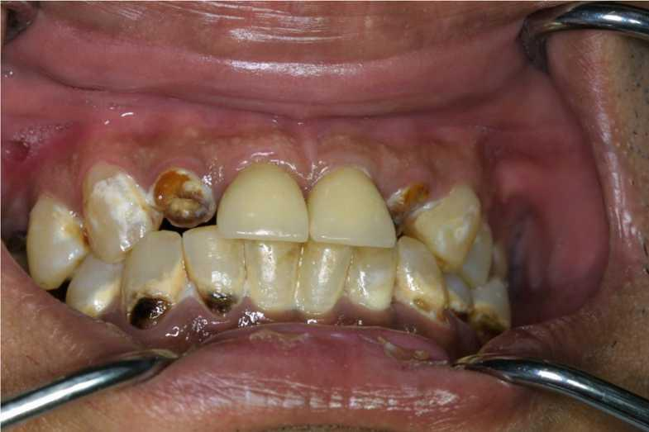

• *Part –b*

*Treatment plan ;-*• *Oral examination- As seen in the above image the mother who*

*ages 40 has grossly decayed teeth for the mandibular teeth 12,22 as seen in the image the mother the lower teeth appears to have cervical caries along with 34,35,42,43 and also for 33 which appears o be having non carious lesion*

*and as the patient is suffering from pain analgesics are advised to relief ,her from the pain*

* *Radiographic Evaluation ;-Take dental x-ray, which is periapical x-ray to determine the extent of the tooth decay and identify the underlying problems , as the tooth appears to be grossly affected and crown destruction is siginificant extraction would the next step*

•

* *Anesthesia ;- the following anterior maxillary teeth 12,22 are to*

*be extracted by numbing the area through local anesthesia to reduce the pain and to reduce patients anxiety over tooth extractions the following anterior superior alveolar nerve block is given*

page8image116053488

9

* *Extraction ;- the following teeth 12,22 need to be extracted and are anterior maxillary teeth .we will use specialized instruments to gently loosen and remove the decayed tooth from its socket. Using maxillary anterior forceps*
* *Post extraction instruction;- After the tooth extraction, we will provide instructions on post-extraction care. This typically includes biting on a piece of gauze for more than 30 minutes to control bleeding and applying an ice pack to minimize swelling. And along with that patient is asked not have hot food and have liquid diet for 24 hrs They may also prescribe pain medications or antibiotics if necessary to reduce the chance of pain and discomfort .*
* *Healing Process: The socket which is left after the tooth extraction will gradually fill with a blood clot and heal over time.*
* *Replacement Option ;- as the tooth extracted are anterior grossly decayed tooth 12,22 and are extracted the best option here would*

*be include dental implants so advice dental implant for the*

*missing teeth*

* *Treatment plan [mandibular part] ;- as seen in the image the*

*mother the lower teeth appear to have cervical caries as seen in the image the mother the lower teeth have cervical caries along with 34,35,42,43 so a class v cavity is to be prepared and filled with GIC cement*

* *Tooth preparation; - Class V lesions that extend onto the root surface the following steps are involved*
* *90 -degree cavo -surface margin with uniform depth of the axial line angles.*
* *Initiated with a tapered fissure carbide bur (no 271) is used at high speed with air water spray. page9image116027584All the external preparation walls should be visible from facial position and should be outwardly divergent . The bevel is given with a flame shaped diamond instrument, resulting in approximately 45 degrees to the*

10

*external tooth surface and prepared to a width of at least 0.5 mm depending on the preparation of the size and esthetic consideration.*

* *Restoration of the prepared class v cavity with GIC cement ;-1*

*the prepared tooth must be free from moisture and it should be*

*clean 2. The consistency of the mixed cement must allow*

*complete coating of the surface irregularities of the tooth with*

*the cavity prepared 3. Excess cement must be removed at the*

*appropriate time to reduce the overflowing of cement 4. surface*

*is to be restoration 6 finishing and polishing to make it aesthetic as they are anterior teeth of a female patient*

* *Fluoride application ;- long with this the patient suffers from generalized fluorosis so fluoride application is important*
* *So the mother ought to brush as a minimum instances every day with a toothpaste containing 1,350-1,500ppm fluoride*
* *And moreover fluoride varnish is applied to the patient teeth . The method includes portray a varnish containing excessive tiers of fluoride onto the floor of the teeth with fluorosis two times*

*a yr to save you decay.. It works with the aid of using strengthening teeth*

*enamel, making it greater proof against decay.*

* *Treatment options for the patient would be ;-, bridges, or removable dentures to restore the appearance and function of the missing tooth. Along with dental implants ,fluoride application*
* *Give diet counsel for reducing the intake of sugar and advice having more protein and fiber rich foods*

•

11

* *finished without excessive drying5 prevent the cracking of the*
* *Treatment plan;-*
* *Oral examination ;-as seen in the image above the child is*

*suffering from early childhood caries along with generalized fluorosis along with cervical and buccal caries on the mandibular region so the maxillary teeth of because the teeth have deep carious lesions*

* *Radiographic examination;- on examination the carious extent is deep so we go for pulpectomy of the teeth*
* *Pulpectomy ;- the patient is given a local anesthesia and isolation with rubber dam then taking a round bur a access is made using a endontic explorer the cananls are founf and then accessible pulp is removed after filling the canals the area should be flushed using hot saline and dried out with paper points a small peglet with cotton wool dipped in formocersol should be placed in pulp chamber for 3 minutes and the canal is filled with slurry creamy paste of zinc oxide paste*
* *For the mandibular teeth;- the following teeth with cervical caries a cavity is prepared using a round bur and then filled with glass ionomer cement*
* *Treatment options;- depending upon radiograph the tooth must be treated with pulp vitality test and later go for direct pulp*

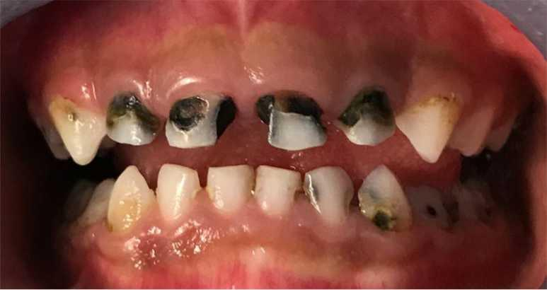

12

*capping or indirect pulp capping should be advised and for the fluorosis the child should be given fluoride application in given time intervals and as the child is aged four years she should be given pit and fissure sealant to avoid the risk of occlusal caries*

• *Give diet counsel for reducing the intake of sugar and advice having more protein and fiber rich foods*

page12image115936304

*For mother the diarise plan ;- 1.extraction*

*2. follow up of the extraction 3.dental implant*

*5.fluoride application*

• *Childs treatment plan diaries*

*1. oral examination 2.pulpectomy of the affected teeth*

*4. fluoride application*

*On the day one  
After a week of extraction Starting the procedure after a week of extraction*

*In given time interval apply fluoride varnish*

*On the day of visit  
Single sitting pulpectomy on the same day*

*Fluoride application in the given time intervals*

page12image115941504page12image115941920page12image115941712page12image115942960page12image115943168page12image115943376

|  |  |
| --- | --- |
| *4.class v cavity preparation for teeth no 34;35;42;43 and cement filling with GIC* | *On the day of check up* |

page12image115945040page12image115945248page12image115945456page12image115945664page12image115945872page12image115946080page12image115946288page12image115946496

|  |  |
| --- | --- |
| *3. treating the lower teeth with caries removal and Applying of GIC cement* | *After a week of pulpectomy* |

|  |  |
| --- | --- |
| *5. application of pit and fissure sealant to prevent occlusal caries* | *Every six month of time interval* |

13

* *Monitoring success for mother ;- the mother is placed with dental implants so she would require follow-up check up to see the bone modulation to the fixature of implant .and further check for the non carious lesion during regular follow ups and monitor the fluoride application to be applied regularly*
* *Look out for change in the diet by giving diet counselling to reduce sugar intake to lower the risk of caries and tooth damage*
* *Advice brushing twice daily*
* *Monitoring success for child ;- as the child has under gone pulpectomy we will have regular follow ups*
* *And call in for check ups for the diet counselling ,*
* *Also monitor the application of fluoride and the right time*

*intervals*

* *Even have the pit and fissure sealant placed every 6 months of*

*time interval*

• *Reference;- 1. Palmer RJ Jr, Chalmers NI, Rickard AH, Kolenbrander PE. Community development in bacterial biofilms of the oral cavity. Microscopy and Microanalysis 2008;14:1554- 1555. 2. Avila M, Ojcius DM, Yilmaz O. The oral microbiota: living with a permanent guest. DNA and Cell Biology*

page13image114693408

14

•

*2009;28(8): 405-411 [3]. Overman PR. Biofi lm: A new view of plaque. J Contempt Dent Pract 2006;1:1-11. [4]. Tatakis DN, Kumar PS. Etiology and pathogenesis of periodontal disease. Dent Clin Nam 2005;49:491-516. [/]Lindhe J, editor. Clinical Periodontology and implant dentistry book, 4th ed. Oxford, UK: Blackwell Publishing C/ompany; 1998*

*[6]. Hajishengallis, E.; Parsaei, Y.; Klein, M.; Koo, H. Advances in the microbial etiology and pathogenesis of early childhood caries. Mol. Oral Microbiol. 2017, 32, 24–34. [CrossRef] [7] Banas, J.A. Virulence properties of Streptococcus mutans. Front. Biosci. 2004, 9, 1267–1277. [CrossRef] [8] Lamont, R.J.; Koo, H.; Hajishengallis, G. The oral microbiota: Dynamic communities and host interactions. Nat. Rev. Microbiol. 2018, 16, 745–759. [CrossRef]*

*[9] Fakhruddin, K.S.; Ngo, H.C.; Samaranayake, L.P. Cariogenic microbiome and microbiota of the early primary dentition: A contemporary overview. Oral Dis. 2019, 25, 982– 995.  
[10]. Jiang, W.; Ling, Z.; Lin, X.; Chen, Y.; Zhang, J.; Yu, J.; Xiang, C.; Chen, H.J. Pyrosequencing analysis of oral microbiota*

*shifting in various caries states in childhood. Microb. Ecol. 2014, 67, 962–969. [CrossRef]*

*[11]. Takahashi, N.; Nyvad, B.J.C.R. Caries ecology revisited: Microbial dynamics and the caries process. Caries Res. 2008, 42, 409–418.  
[12]Socransky SS, Haffajee AD, Cugini MA, et al.. Microbial complexes in subgingival plaque. J Clin Periodontol. 1998;25: 134-144.[13] . Socransky SS, Haffajee AD, Ximenez-Fyvie LA, et al.. Ecological considerations in the treatment of Actinobacillus actinomycetemcomitans and Porphyromonas gingivalis periodontal infections. Periodontol 2000. 1999;20: 341-362*

•

•

• •

•

•

15

* *[14]. Socransky SS, Haffajee AD. Periodontal microbial etiology. Periodontol 2000. 2005;38: 135-187.[15] Kojima T, Yasui S, Ishikawa I. Distribution of Porphyromonas gingivalis in adult periodontitis patients.. J Periodontol. 1993;64: 1231-1237*
* *[16] Costerton JW, Stewart PS, Greenberg EP. Bacterial biofilms: a common cause of persistent infections. Science. 1999;284: 1318-1322 - [17] Thomas JG, Nakaishi LA. Managing the complexity of a dynamic biofilm. J Am Dent Assoc.. 2006;137(11 suppl): 10S-13S*
* *[18] . Grossi S, Mealey BL, Rose LF. Effects of periodontal infection on the systemic condition. . In: Rose LF, Mealey BL, Genco RJ,*
* *Cohen W. , editors. Periodontics: Medicine, Surgery and Implants. St. Louis, MO: Elsevier Mosby; 2004*
* *[19]. Cieplik, F.; Rupp, C.M.; Hirsch, S.; Muehler, D.; Enax, J.; Meyer, F.; Hiller, K.-A.; Buchalla, W. Ca2+ release and buffering effects of synthetic hydroxyapatite following bacterial acid challenge. BMC Oral Health 2020, 20, 85 [20] Kensche, A.; Holder, C.; Basche, S.; Tahan, N.; Hannig, C.; Hannig, M. Efficacy of a mouthrinse based on hydroxyapatite to reduce initial bacterial colonisation in situ. Arch. Oral Biol. 2017, 80, 18–26.*
* *[21] Liu, J.-F.; Hsu, C.-L.; Chen, L.-R. Correlation between salivary mutans streptococci, lactobacilli and the severity of early childhood caries. J. Dent. Sci. 2019, 14, 389–394 [22] Grychtol, S.; Basche, S.; Hannig, M.; Hannig, C. Effect of CPP/ACP on Initial Bioadhesion to Enamel and Dentin in situ. Sci. World J. 2014, 2014, 512682.*
* *[23] Jasmin, K.; Matthias, H.; Pia, W.; Sabine, B.; Birgit, L.; Norbert, P.; Anna, K.; Christian, H. Influence of pure fluorides and stannous ions on the initial bacterial colonization in situ. Sci. Rep. 2019, 9, 18499*

16